
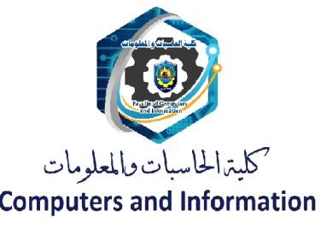

Blood donatioan and disease prediction system
(Blood Samples)

DMU, Feb 2024

We hereby certify that this senior project submitted by the project teamwork
Conforms to acceptable standards and is fully adequate in scope and quality to
Fulfill the seminar requirements for the degree of Bachelor of Computer Science and Information Technology

Supervision:
Dr/ Ahmed Saleh Eng/ Eman Anwar

Abstract:
As we all know blood donation is a fundamental process, every day blood seekers are in continuous increasing, and in some cases the blood donor may arrive after it’s too late or unfortunately the patient has already dead, and there are many cases such the people who are in a need of blood continuously or they may need a huge amount of blood according to the blood they lost, however the blood donation process maybe somehow not flexible or not easy, so our system will help in this process basically to ease the process of donation first on the donor and in the other hand it will save the life of the patient.

Although many of us sometimes have a samples or genetics may cause to us a disease or even some symptoms that we ignore them and later we discover that we are having a dangerous disease, those symptoms are not much harmful or some people consider them as an ordinary thing however they may be the reason of a dangerous disease.

Contents
Abstract: 1
1. Introduction iii
1.1 Problem and Idea .
1.2 Features actor 1
1.3 Document Organization 3
2. Background 5
AI (Machine Learning) .
Back-End Development .
Front-End Development .
Moblie Development .
3. Relational Work…………………………………………………………………………14
4. Analysis and Design 17
4.1 System Overview 17
4.1.1 Business Needs 17
4.1.2 System Users .
4.2 System Analysis & Design 23
4.2.1 Use Case Diagram 23
Use Case Diagram 31
4.2.2 system sequence diagram .
4.2.3 Data Flow diagram .
4.2.4 Entity relationship Diagram .
4.2.5 Class Diagram .
5. Project 17

Introduction

Welcome to the documentation for our Graduation Project, an innovative application designed to revolutionize blood donation and disease prediction. In today's fast-paced world, the need for efficient and accessible healthcare solutions is more critical than ever. Our project aims to address two vital aspects of healthcare – blood donation facilitation and disease prediction – through the power of technology.
The primary objective of our application is to bridge the gap between blood donors and those in need, streamlining the process of blood donation and ensuring timely access to this life-saving resource. By leveraging modern technology, we seek to create a platform that not only connects donors with seekers but also simplifies the entire donation process, from registration to donation scheduling.
In addition to facilitating blood donation, our application incorporates a groundbreaking feature – disease prediction. By analyzing symptoms and samples provided by users, our app employs advanced algorithms to predict the likelihood of certain diseases. This predictive capability has the potential to significantly impact early diagnosis and intervention, ultimately saving lives and improving healthcare outcomes.
Through this project, we aspire to make a meaningful contribution to the healthcare landscape by harnessing the power of technology for the greater good. By promoting blood donation and enhancing disease prediction, we aim to create a healthier and more connected community.
Join us on this journey as we embark on the development of a transformative application that has the potential to make a lasting impact on healthcare delivery.

1.1 Problem and Idea
In contemporary society, accessing timely blood donations and accurately predicting diseases remain significant challenges within the healthcare sector. The existing processes for blood donation often lack efficiency and accessibility, leading to critical shortages in times of need. Furthermore, early detection and prediction of diseases based on symptoms and samples can be complex and time-consuming, potentially delaying vital medical interventions.
Our project aims to address these challenges by developing an innovative application that serves two primary purposes: facilitating blood donation and enhancing disease prediction.
Blood Donation Facilitation:
The project recognizes the inefficiencies and barriers present in traditional blood donation systems. These include limited visibility of donation centers, cumbersome registration processes, and difficulties in matching donors with recipients in urgent situations. Our application seeks to streamline the entire blood donation process by providing a centralized platform that connects willing donors with individuals or organizations in need of blood. Through intuitive user interfaces and features such as real-time location-based searches and scheduling capabilities, the app aims to increase the accessibility and efficiency of blood donation, ultimately saving lives in critical situations.
Disease Prediction:
Early detection and prediction of diseases play a crucial role in improving healthcare outcomes and saving lives. However, accurately diagnosing diseases based on symptoms and samples can be challenging, especially in resource-constrained settings. Our application leverages cutting-edge machine learning algorithms to analyze user-provided symptoms and samples, generating predictions regarding the likelihood of specific diseases. By empowering individuals with timely insights into their health status, the app aims to facilitate early intervention and proactive healthcare management, ultimately improving health outcomes and reducing the burden on healthcare systems.

In summary, our project seeks to revolutionize healthcare delivery by creating a comprehensive application that addresses the critical issues of blood donation facilitation and disease prediction. By harnessing the power of technology, we aim to empower individuals and healthcare providers alike, facilitating better access to essential healthcare services and ultimately saving lives.

1.2 features actors
Patients across the country need blood on a continuous and regular basis due to critical conditions, surgeries, or similar situations. And Hospitals should provide suitable blood bags for the patients' blood. However, there are times when there is a shortage of blood in some hospitals and regions, and the available blood may not be sufficient, or in other cases, there may be no blood compatible with the patient's blood type. On the other side, there are individuals seeking to monitor their health either periodically or due to the emergence of certain worrisome symptoms. So, it is necessary to enhance blood supply and improve healthcare through the use of an innovative application. The project aims to facilitate the blood donation process by enabling indirect communication between the patient and the donor. This contributes to enhancing healthcare quality and providing capabilities for disease prediction. The web application enables easy communication between patients and blood donors, facilitating the donation process and efficiently identifying needs. The application also provides a location tracking feature for donors, facilitating the sending of donations and communication during emergencies. The project allows donors to input their health data, enabling the system to analyze this information and provide an accurate assessment of their health condition. By gathering a set of health data from users, the system can predict and analyze potential diseases, contributing to early intervention and prevention. The application also provides regular monitoring of the health of donors and users, along with reminder notifications for check-ups and routine examinations.
The project aims to:

*Improve blood donation processes and encourage more individuals to participate.
*Provide a secure environment for the exchange of health information between patients and donors.
Offer tools for disease prediction and proactive preventive measures.
This graduation project reflects a commitment to improving the healthcare sector and encouraging more effective blood donation through technological innovation. By combining effective communication and health data analysis, the project aims to bring about a positive change in the experiences of both patients and donors.

1.3 Document Organization
In chapter 2 we are taking about the analysis of our system step by step such as
Use case, domain model diagram, system sequence diagram, data flow diagram and class diagram.
In Chapter 3, you will see a set of evaluations tools that help design the different devices, also
To bring down whole knowledge of requirements and analysis on the desk and design the software product.
The inputs from users and information gathered in requirement gathering phase are the inputs of this step. The output of this step comes in the form of two designs; logical design and physical design. Engineers produce meta-data and data dictionaries, logical diagrams, data-flow diagrams and in some cases pseudo codes.
In Chapter 4 to talk about Android and web app as it began an independent technology transfer and
This means installing the software on user machines. At times, software needs post-installation configurations at user end. Software is tested for portability and adaptability and integration related issues are solved during implementation.
This step is also known as programming phase. The implementation of software design starts in terms of writing program code in the suitable programming language and developing error-free executable programs efficiently.
Measurement of heart rate and various degrees of heat, and also we are taking about planning and tracking the health of the user.
Will save the health record in his application to enable him to serve, and save or delete and others.
In Chapter 5 we will take on the importance of following up the mobile application and web application with Wearable to user.
An estimate says that 50% of whole software development process should be tested. Errors may ruin the software from critical level to its own removal. Software testing is done while coding by the developers and thorough testing is conducted by testing experts at various levels of code such as module testing, program testing, product testing, in-house testing and testing the product at user’s end. Early discovery of errors and their remedy is the key to reliable software.

Background

Relational work
- IDonor

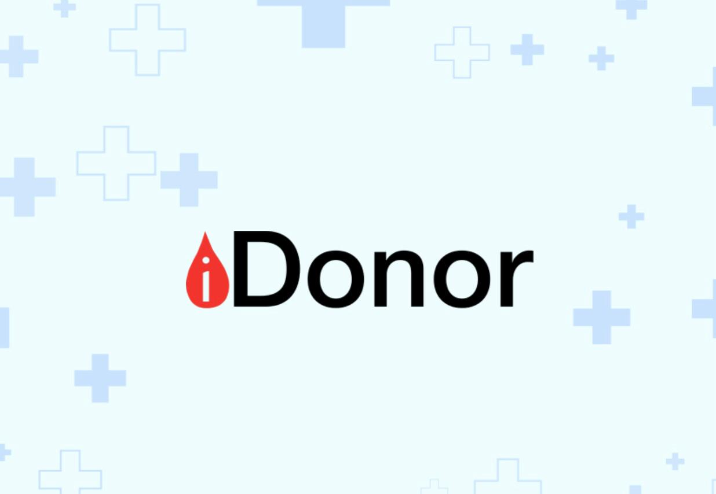
An application that helps establish a link between the person who needs blood and the person who can donate blood, which saves the trouble of searching for a blood donor.
The program is divided into two parts: the first part is that the user donates and the second part is that the user searches for a donor, so he chooses the blood type he is looking for.
A person with type “B+” receives a warning in the event of a need for blood type “B+”. If the subscriber donates blood, he does not receive any warning regarding the blood request for two months, as the person cannot donate blood again until two months have passed.
The difference between these sites and our project:
- The user can also test his health and not just donate blood.
- It will can determine the location of the user.
- Users who register will receive notifications when someone within 5 miles needs blood, enabling them to donate at nearby clinics.
- Raising awareness of the benefits of blood donation and contraindications for blood donation
- Includes incentives to encourage regular blood donation. Every successful donation earns the donor a star.

- DEFINIK
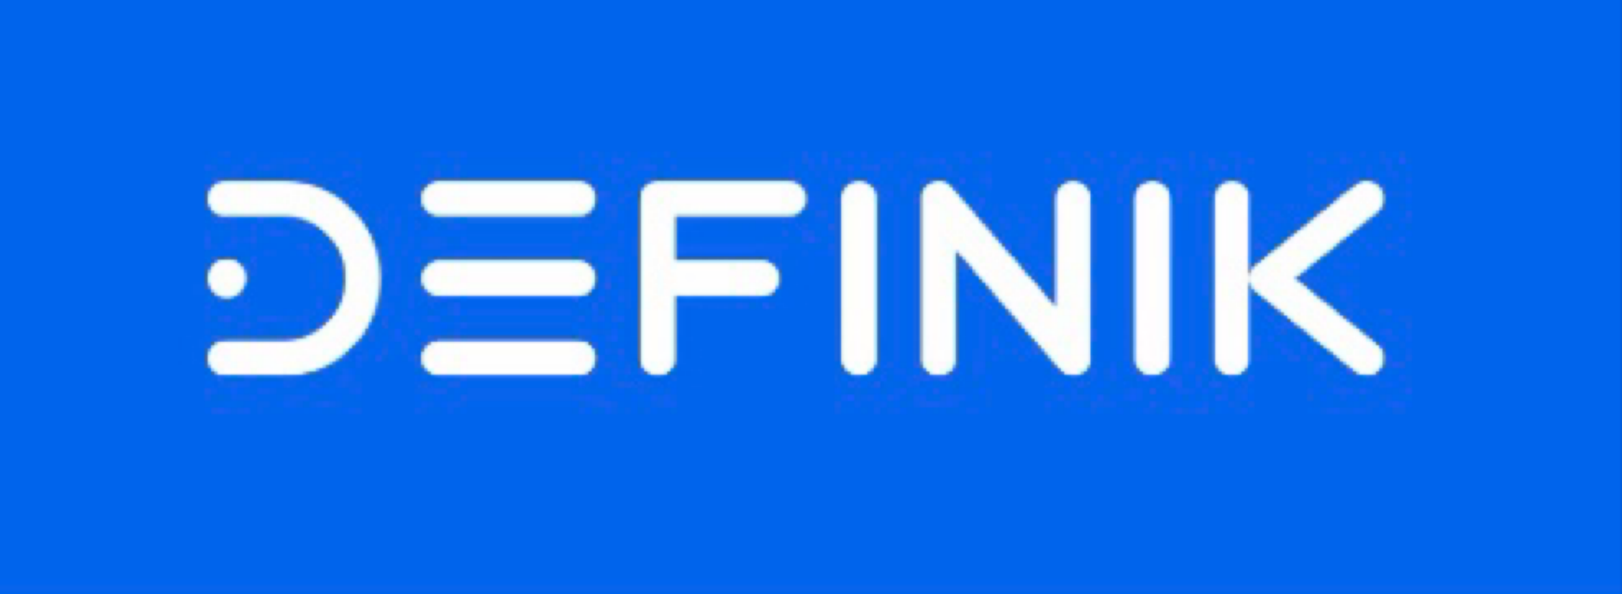
Definik is a fast and cheap solution for early risk detection of common diseases by analyzing laboratory blood tests and creating personalized plan for further monitoring with regular recommendations based on AI.
Definik includes regular monitoring, which helps to track changes in the user's health status and provides timely recommendations.
With Definik users can receive early risk detection of a range of conditions allowing them to take action before symptoms worsen.
This personalized approach ensures that users receive the support they need to manage their health proactively.
Everyone can use Definik because of its simple interface.
With Definik, users can take control of their health and live life to the fullest.

The difference between Definik and our application.
– Definik application:
- The diagnosis of diseases depends on laboratory blood tests.
– our application (blood samples):

• The diagnosis of diseases depends on several questions and inquiries related to the user in order to know the predicted disease and the way to reach an appropriate solution.
• It will connect with someone of relatives to alarm him if the user in danger.

Analysis and Design

System Overview
4.1.1 Business Need:
Our application aligns with various business needs within the healthcare sector, catering to the demands of stakeholders including donors, recipients, healthcare providers, and regulatory authorities. The following are the key business needs that our app aims to fulfill:
- Improved Access to Blood Donation Services:
  - Addressing the growing demand for blood donations by providing a user-friendly platform that connects donors with recipients seamlessly.
  - Enhancing the visibility of donation centers and increasing donor participation through targeted outreach and engagement strategies.
  - Streamlining the donation process to ensure timely access to blood supplies for patients in need, thereby reducing the risk of critical shortages and improving patient outcomes.
- Enhanced Disease Prediction and Prevention:
  - Empowering individuals with valuable insights into their health status through predictive disease analysis based on symptoms and samples.
  - Facilitating early detection and intervention for various diseases, thereby reducing healthcare costs associated with late-stage treatments and hospitalizations.
  - Supporting healthcare providers in delivering personalized care plans and interventions based on predictive analytics, ultimately improving patient outcomes and satisfaction.
- Efficient Resource Allocation:
  - Optimizing resource allocation within the healthcare system by facilitating targeted blood donation campaigns and interventions based on predictive disease trends.
  - Minimizing wastage of blood supplies through accurate demand forecasting and inventory management, ensuring optimal utilization of resources and cost savings for healthcare organizations.
- Regulatory Compliance and Data Security:
  - Ensuring compliance with regulatory standards and guidelines governing blood donation and healthcare data management.
  - Implementing robust data security measures to safeguard sensitive information collected from users, including personal health data and donation records.
  - Providing transparency and accountability in data handling practices to build trust among users and regulatory authorities.
- Scalability and Sustainability:
  - Designing a scalable and adaptable platform capable of accommodating future growth in user base and service offerings.
  - Establishing sustainable partnerships with healthcare institutions, blood banks, and regulatory agencies to support long-term viability and impact.
  - Continuously innovating and evolving the app based on user feedback, technological advancements, and emerging healthcare trends to maintain relevance and effectiveness in the market.
By addressing these critical business needs, our application aims to create value for stakeholders across the healthcare ecosystem, ultimately contributing to improved patient outcomes, operational efficiency, and public health outcomes.

System Users

Our application caters to three primary user roles within the healthcare ecosystem: donors, receivers, and blood banks. Each user role is associated with specific responsibilities and functionalities tailored to their needs. Additionally, both donors and receivers have the capability to utilize disease prediction features alongside their primary roles.
- Donors:
  - Description: Individuals willing to donate blood to support patients in need.
  - Roles and Responsibilities:
    - Registering on the platform and providing personal information, including blood type and medical history.
    - Browsing and participating in blood donation camps organized by blood banks.
    - Scheduling blood donation appointments at designated locations or events.
    - Accessing disease prediction tools to assess their health status and potential risks.
- Receivers:
  - Description: Individuals or healthcare facilities requiring blood transfusions for medical treatment.
  - Roles and Responsibilities:
    - Registering as recipients and providing relevant medical information, such as blood type and urgency of need.
    - Searching for compatible blood donors based on location, blood type, and availability.
    - Sending requests for blood donations and communicating with potential donors or blood banks.
    - Utilizing disease prediction features to monitor their health status and receive early warnings of potential illnesses.
- Blood Banks:
  - Description: Organizations responsible for collecting, storing, and distributing blood donations.
  - Roles and Responsibilities:
    - Organizing blood donation camps and events to facilitate donor participation.
    - Managing donor registration and screening processes to ensure blood safety and suitability for transfusion.
    - Maintaining an inventory of available blood units and managing distribution to meet recipient demands.
    - Collaborating with donors, receivers, and healthcare providers to coordinate blood donation and transfusion activities.
By accommodating the needs of donors, receivers, and blood banks within the application, we aim to streamline the blood donation process, improve access to blood supplies, and enhance disease prediction capabilities for the benefit of all stakeholders involved in the healthcare continuum.

System Analysis & Design

4.2.1 Use Case Diagram

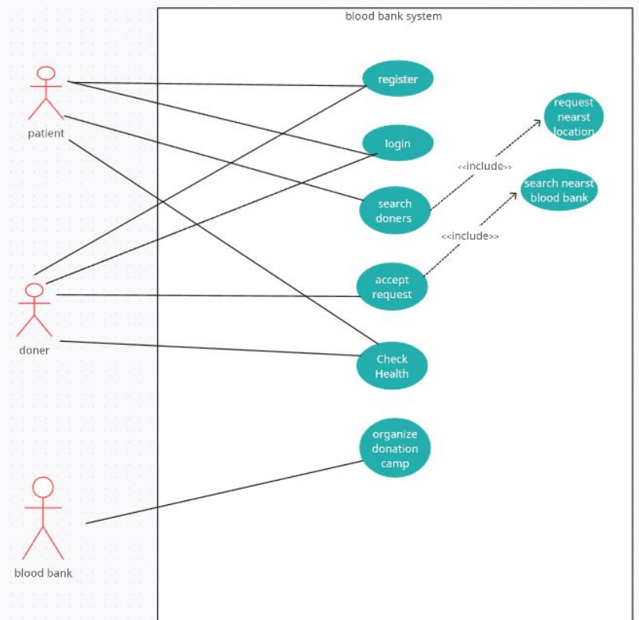

4.2.2 System sequence diagram

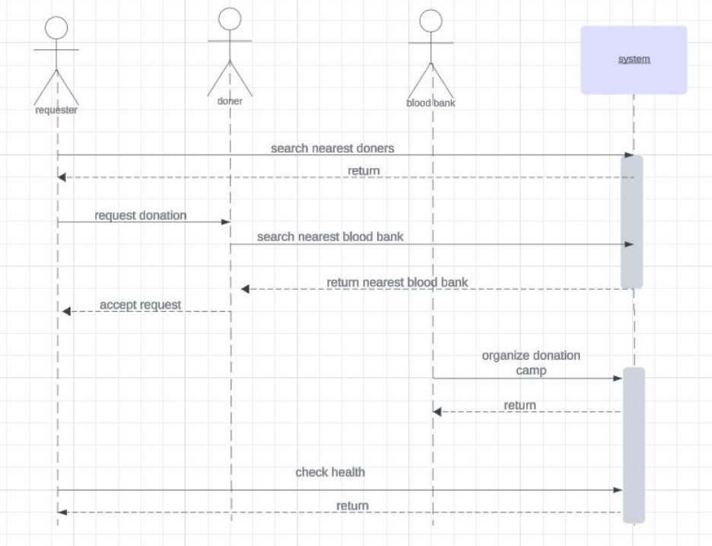

4.2.3 Data flow diagram

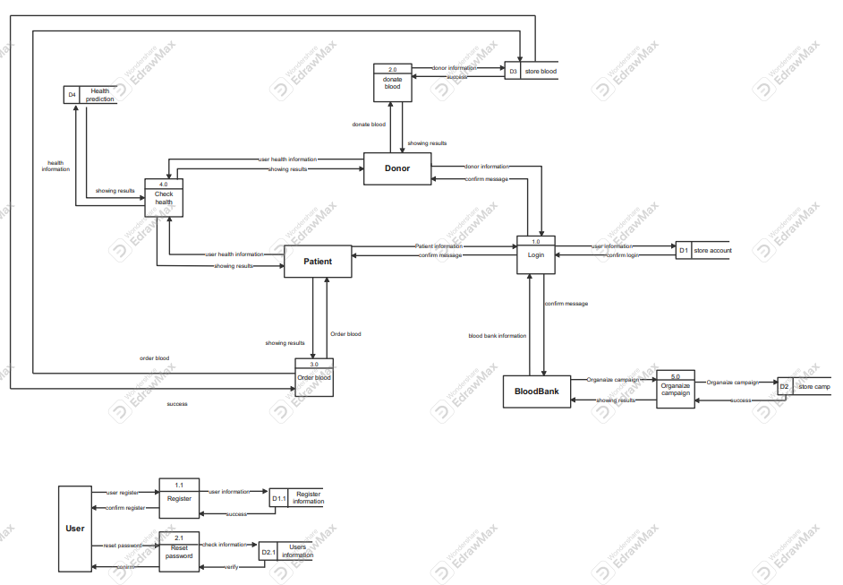

Entity relationship diagram (ERD)
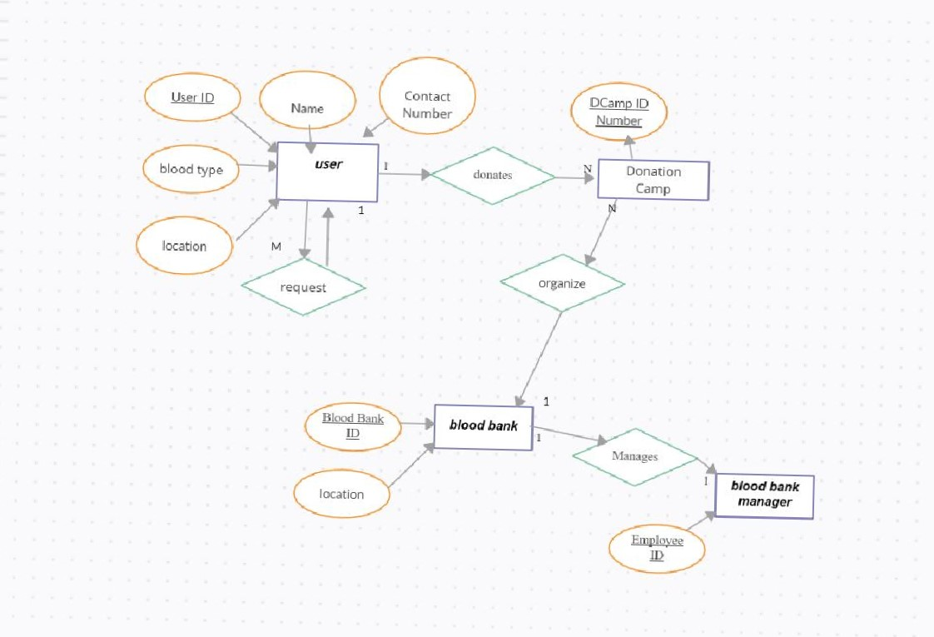

Class diagram

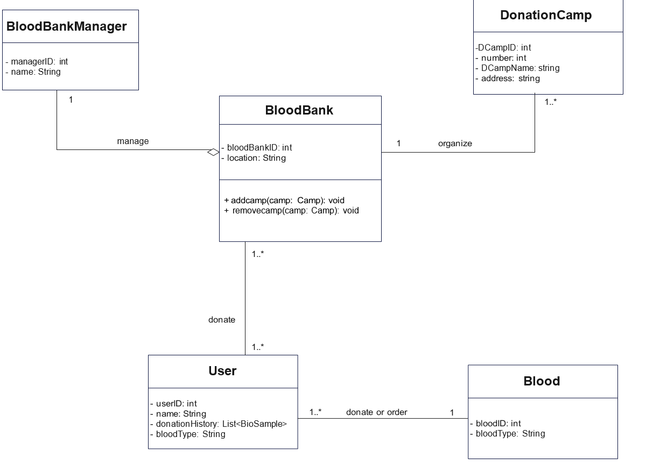

5. Project

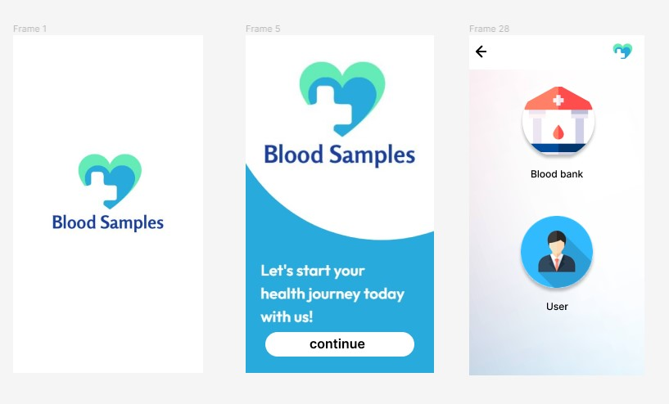
This is the splash and welcome screen and entry screen as it allows the users and the blood bank organization to enter to tha app and use it .

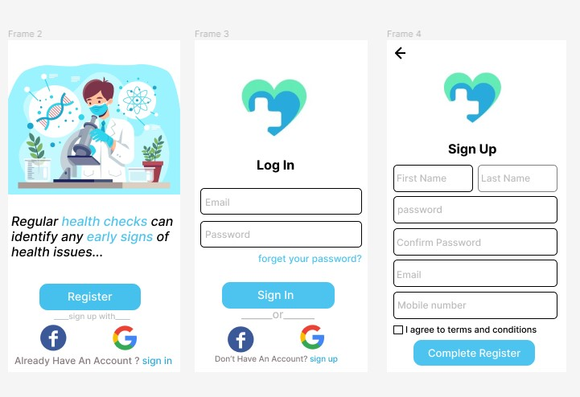

Thesse are registration pages for User in the application as the user can sign up for the app by using the Name ,Password,Email and Phone number and log in to the application using Email and the password.

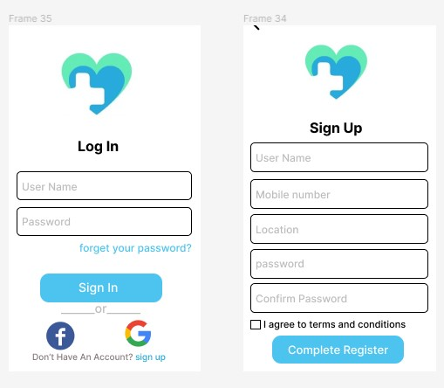

Thesse are registration pages for Blood bank in the application as the blood bank can sign up for the app by using the User name ,Password,Location and Phone number and log in to the application using UserName and the password.

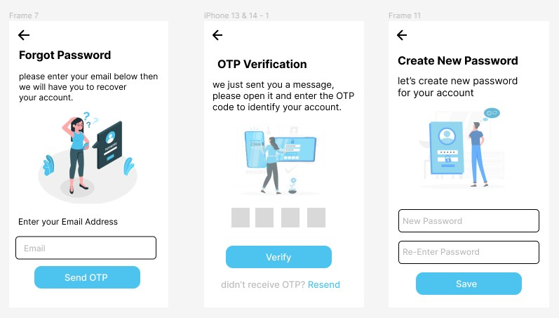

These are pages for forget password for the User as the user can enter his email and we can send him OTP verification code to create a new password and enter the application again and use it.

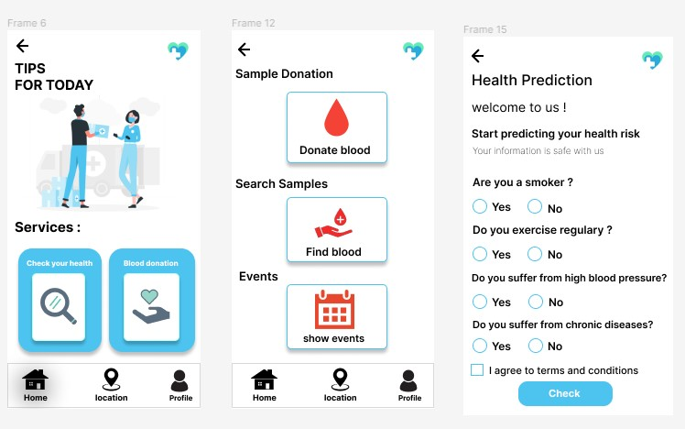

These is the home page and services for the user as the user can check for his health and makes prediction and regular checks and the user also can donate and find blood if he needs and show events that can donate in them .

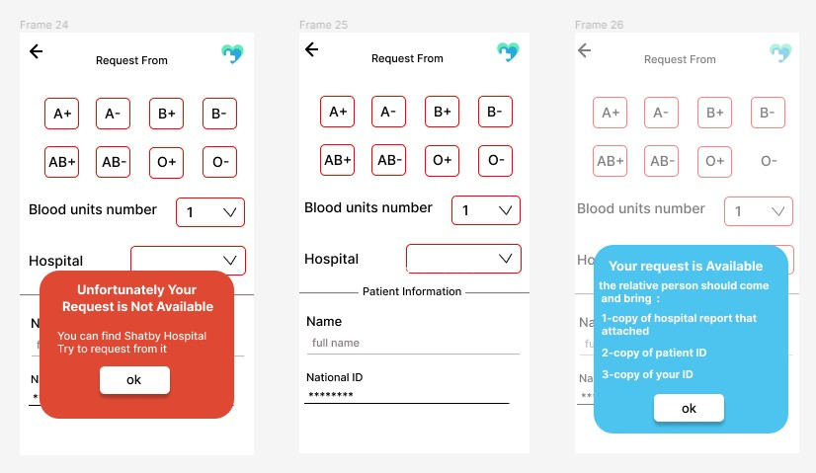

These are page for request form for the user that needs the blood so he can send requests to other to find a donor by selecting the blood type and the hospital he spends so it facilats the donation process.

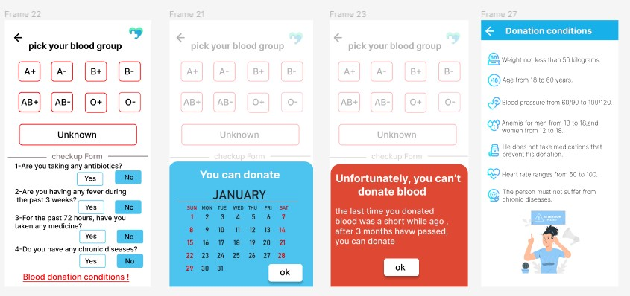

This is the form for the donor that wants to donate to others so he enters and select his blood type and the date he wants to donate in and there this a condition list to recognize him about the donation process .

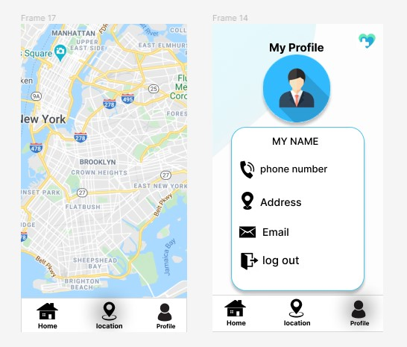

These are the location page and profile page as which the user that wants blood can match with people in his area and send requests to them , in the other hand the donors matches their location for the people who wants blood also .
The profile page conatains the phone number and the address and the email for the user .

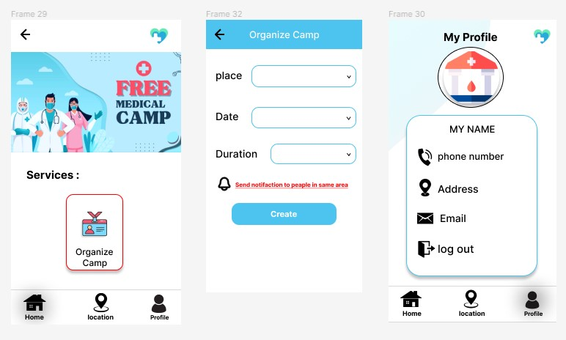

These are the pages for the blood bank as the home page contains services which is organizing a camp as the Blood bank can Organize the camp and matches the location of people with the camp location ,organizing the camp by using its place and date and the duration of the camp , all of this is a free medical for users .

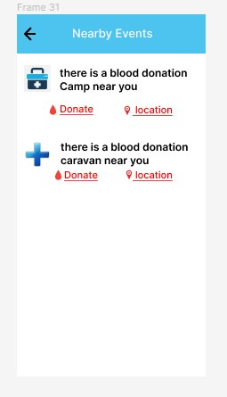

This is the nearby events for the user that can donate in it in his area.

جامعه دمنهور
كليه الحاسبات والمعلومات

مشروع تخرج مقدم كجزء من متطلبات الحصول على درجه البكالوريوس في الحاسبات والمعلومات

مقدم من :
إيهاب ابوالنجا
أحمد عوض صابر
هاجر علي الجمال
سلمى سعيد محمود
أحمد محمد الوكيل
أحمد عبدالمنعم
صلاح مُفلح
محمد ناصر

تحت اشراف:
د/أحمد صالح
وبمساعدة:
م/إيمان أنور

البحيرة-فبراير-2024

الملخص

دلوقتى كل يوم ف حياتنا اليوميه بنسمع عن حالات وفاه كتير وعن حالات محتاجة لدم بكمية كبيرة يوميًا وحالات لفصايل دم اوقات تكون نادرة ولا يوجد في مخزون المستشفى ما يناسب تلك الفصايل لاسعاف المريض اللذي يكاد يفارق الحياة وايضًا عدم وجود الوعي الكافي لعامة الناس بالتبرع بالدم وعدم وجود سهولة كافية في عملية التبرع بالنسبة للمتبرعين او المرضى واهاليهم المحتاجين للدم أما ان يجد متبرع في الوقت الملائم اما ان يشتري الدم بثمن باهظ وهذا ليس حل فعال ولا حل يناسب الجميع وايضًا من الممكن ان المتبرع قد يحمل دمًا به مرض او مُعرض لمرض ما بشكل ما ومن ثم عندما يأتي ذلك المرض نتساءل عن السبب ويكون ذلك السبب هو اهمال المريض بفحص دمه او اهمال بعض الاعراض البسيطة لذلك احنا فكرنا فى عمل مشروع يقوم بحل هذه المشكله وهى عمل تطبيق قادر على تسهيل عملية التبرع وقيادة المتبرع مباشرة لبنك الدم او للمريض المحتاج دم بشكل فوري او اسعاف مريض ما في حالة طارئة يحتاج للدم بشكل كبير وفوري وايضًا فحص الحالة الصحية للدم بعد التبرع ليطمئن على صحته او ترشيح بعض الوقايات اذا كان ذو مرض او مُعرض لمرض ما.

